1)Install git.
sudo yum install git -y
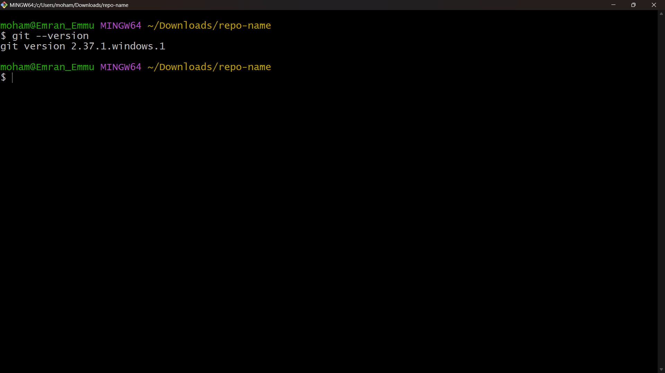

2)Create a repo in github with README.md and .ignore file.
Log in to GitHub.
Click New Repository → Give name.
Select:
- ✅ Initialize with README.md
- ✅ Add .gitignore (choose template, e.g., Linux)
Click Create Repository.

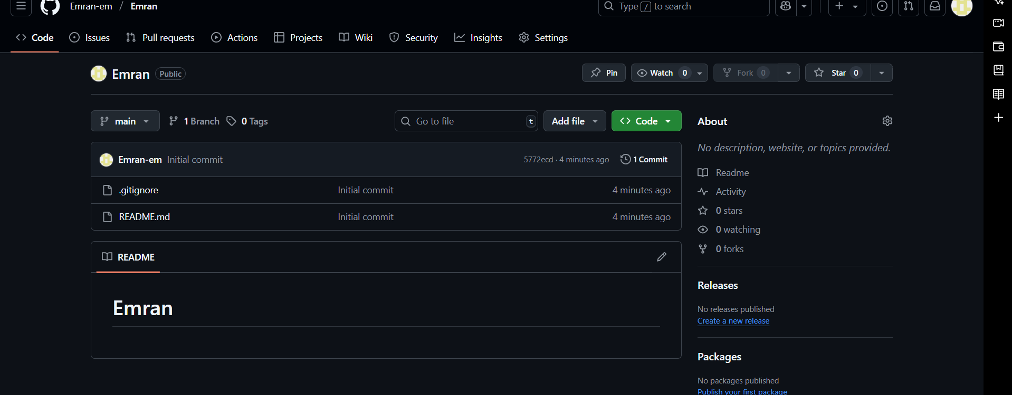
3)Clone the created repo to local.
Copy the repo HTTPS/SSH URL from GitHub:
git clone https://github.com/<username>/<repo>.git
OR via SSH:
git clone git@github.com:<username>/<repo>.git
4)Create two files in local repo
cd <repo>
touch file1.txt file2.txt
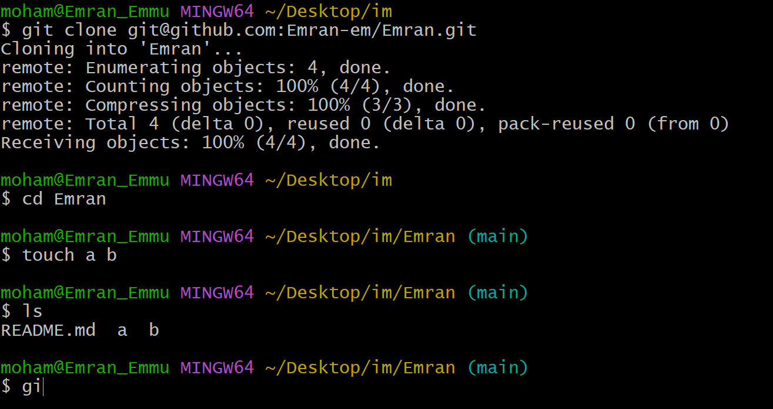
5)Commit two files and push to central Repository.
git add file1.txt file2.txt
git commit -m "Added two files"
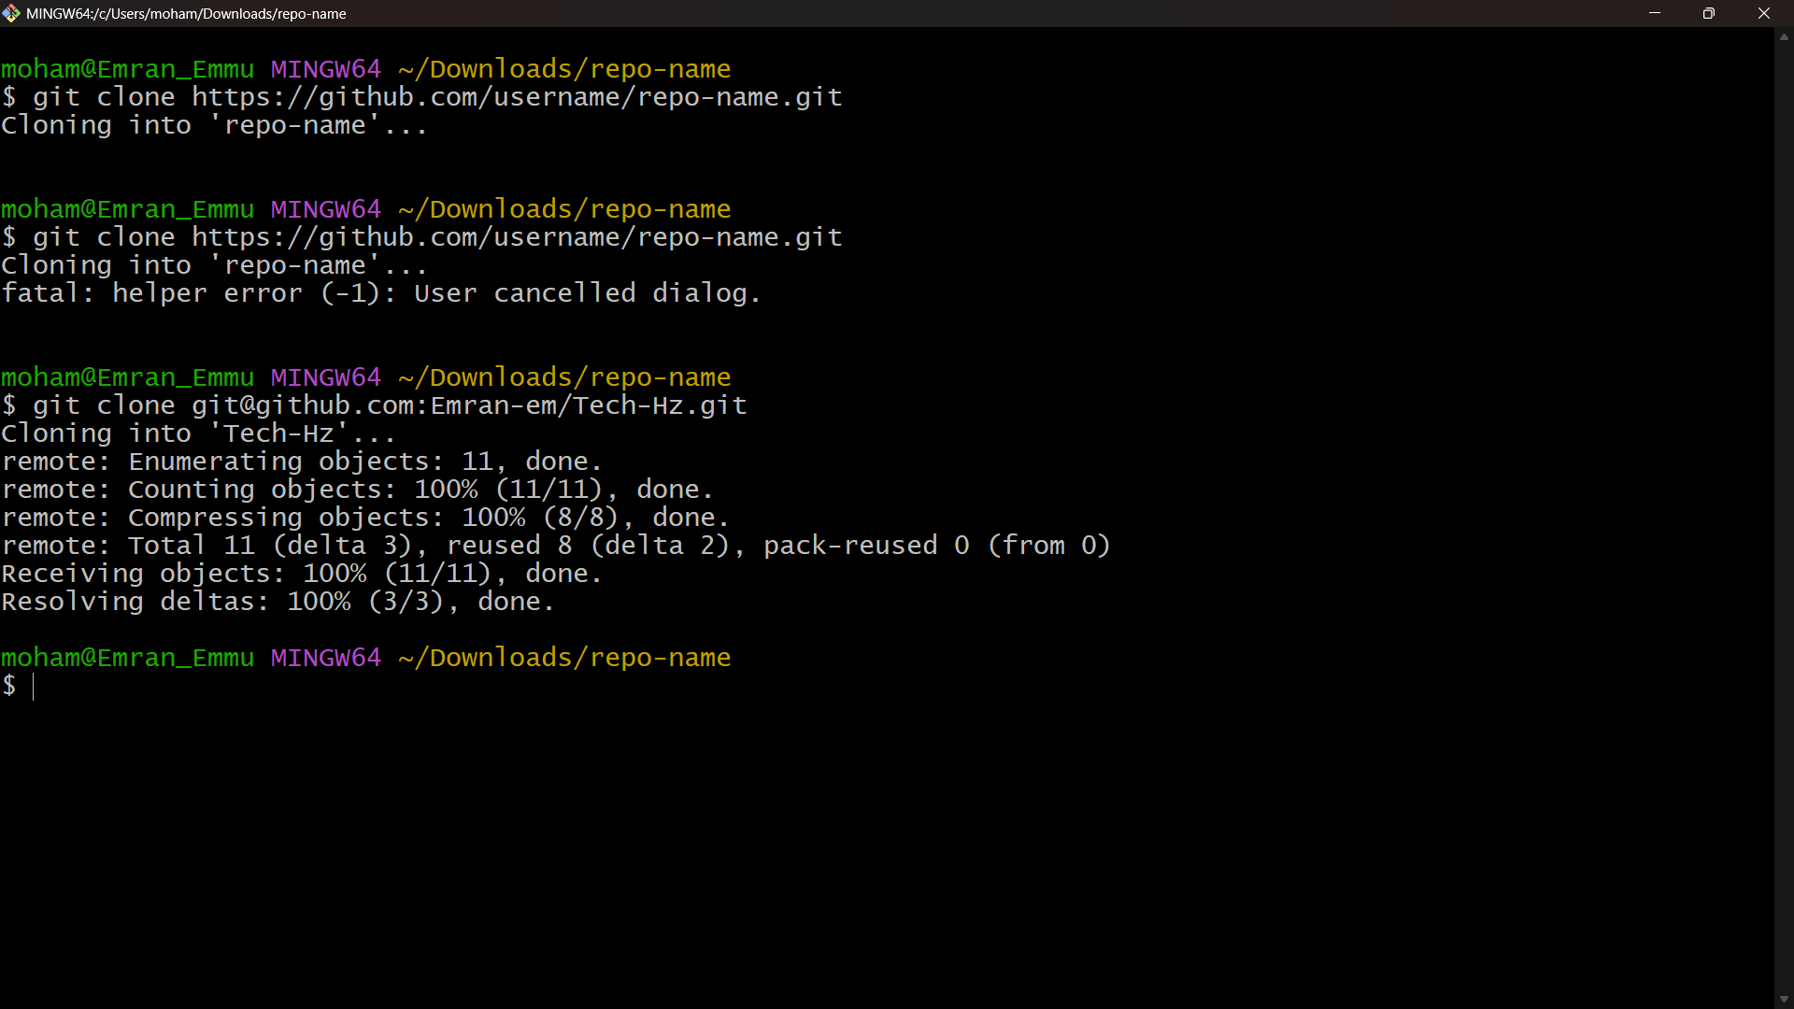
git push origin main

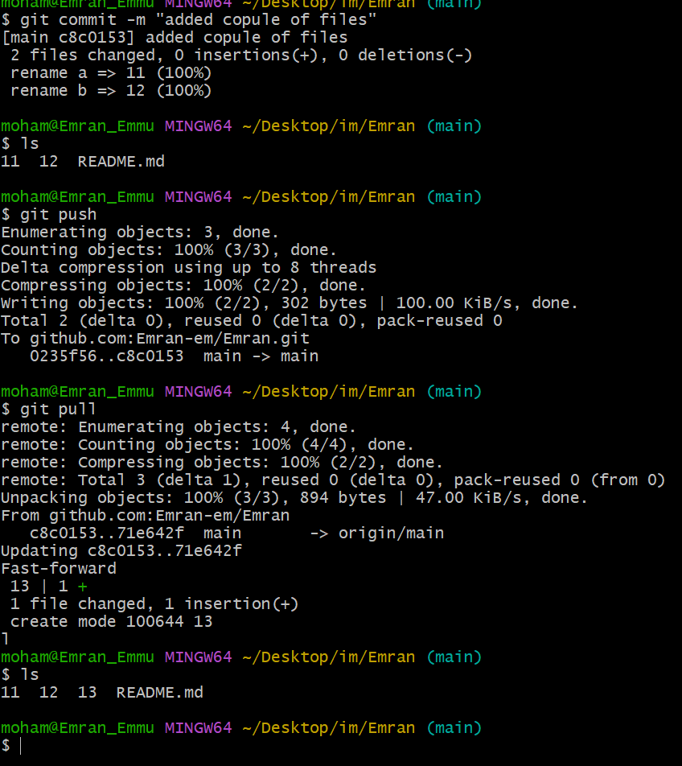

6)Create a branch in local and create a sample file and push to central.
git checkout -b feature-branch
touch sample.txt
git add sample.txt
git commit -m "Added sample file in feature-branch"
git push origin feature-branch
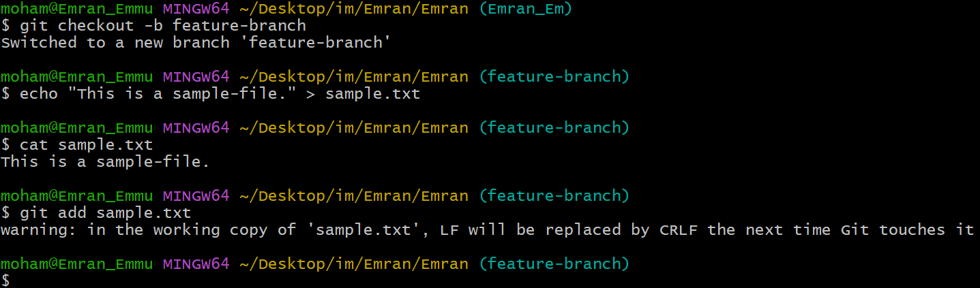
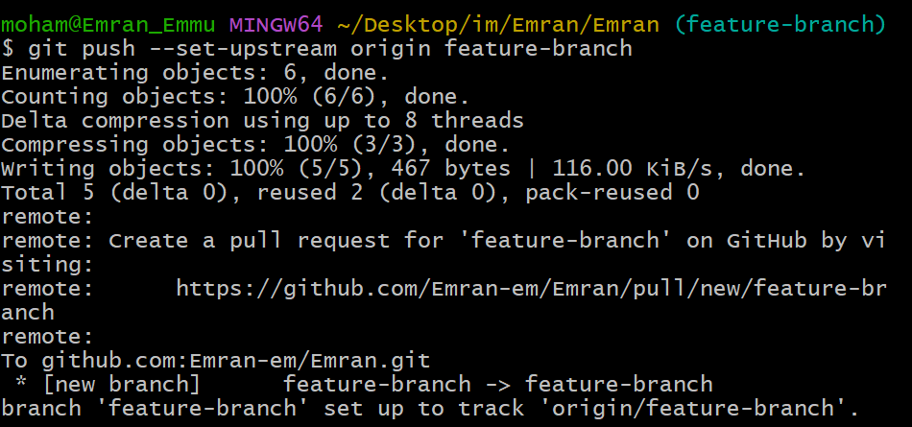

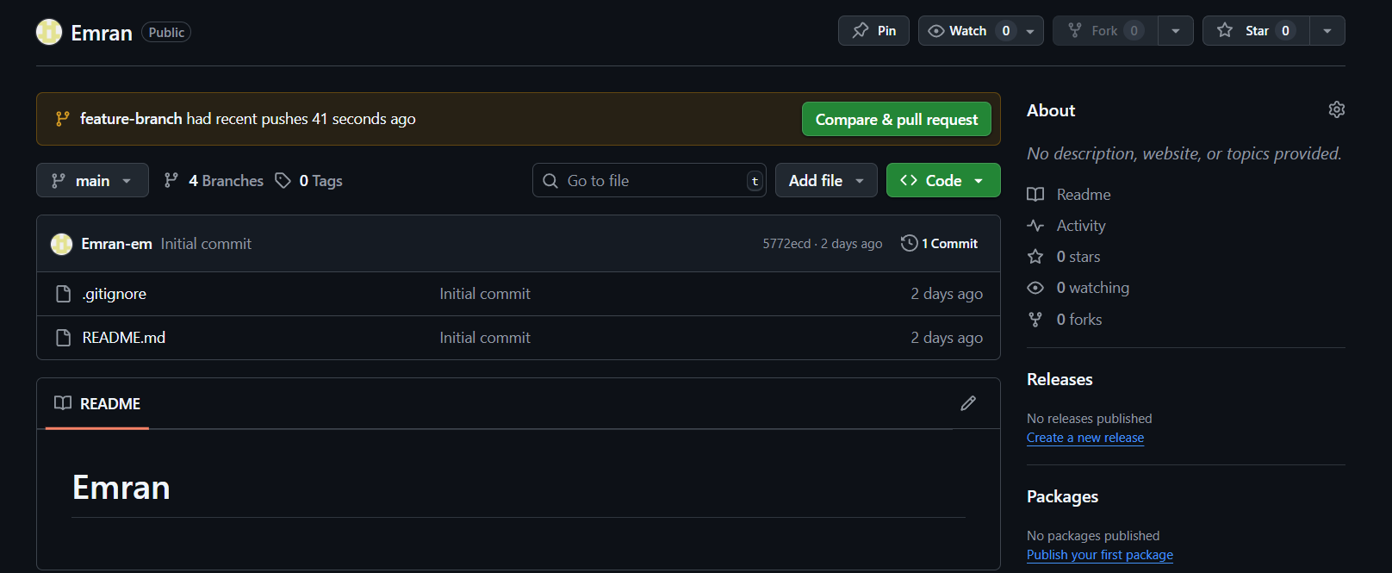
7)Create a branch in github and clone that
Go to GitHub → Click Branches → Create new branch github-branch.
Then pull it locally:
git fetch origin
git checkout github-branch

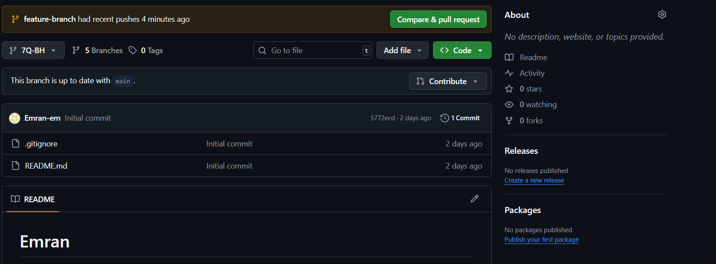

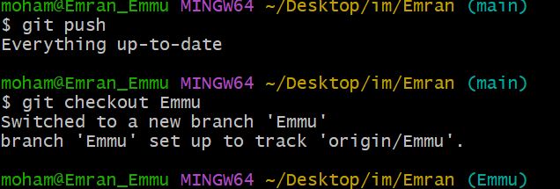
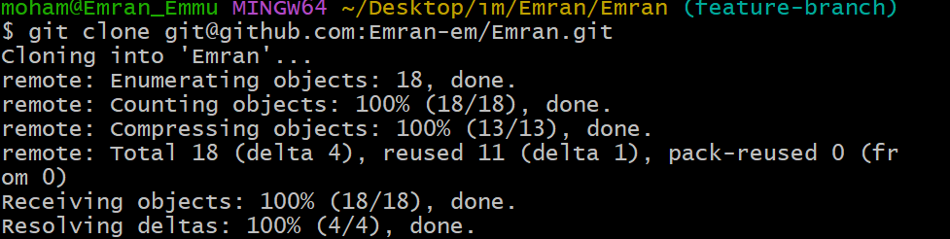
8)Merge the created branch with master in git local.
git checkout main
git merge feature-branch
git push origin main
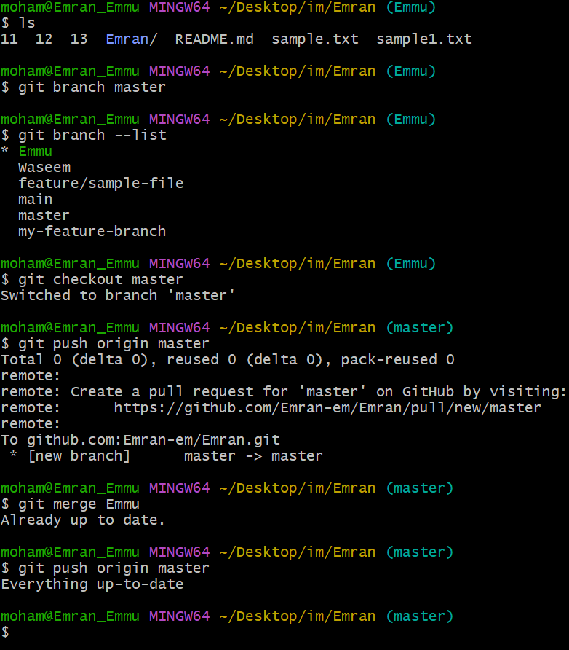

9)Merge the created branch with master in GitHub by sending a pull request.
Go to GitHub → Compare & Pull Request.
Select base: main and compare: feature-branch.
Create Pull Request → Merge.

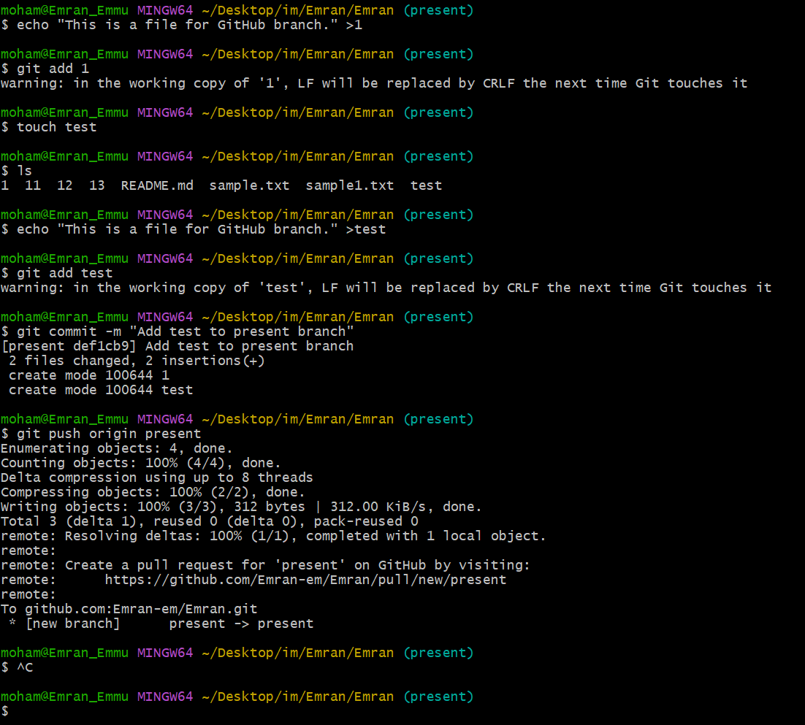

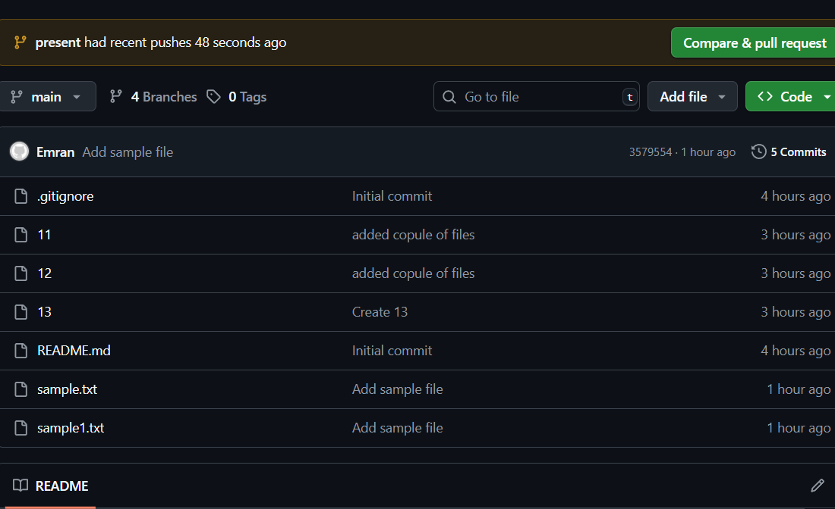
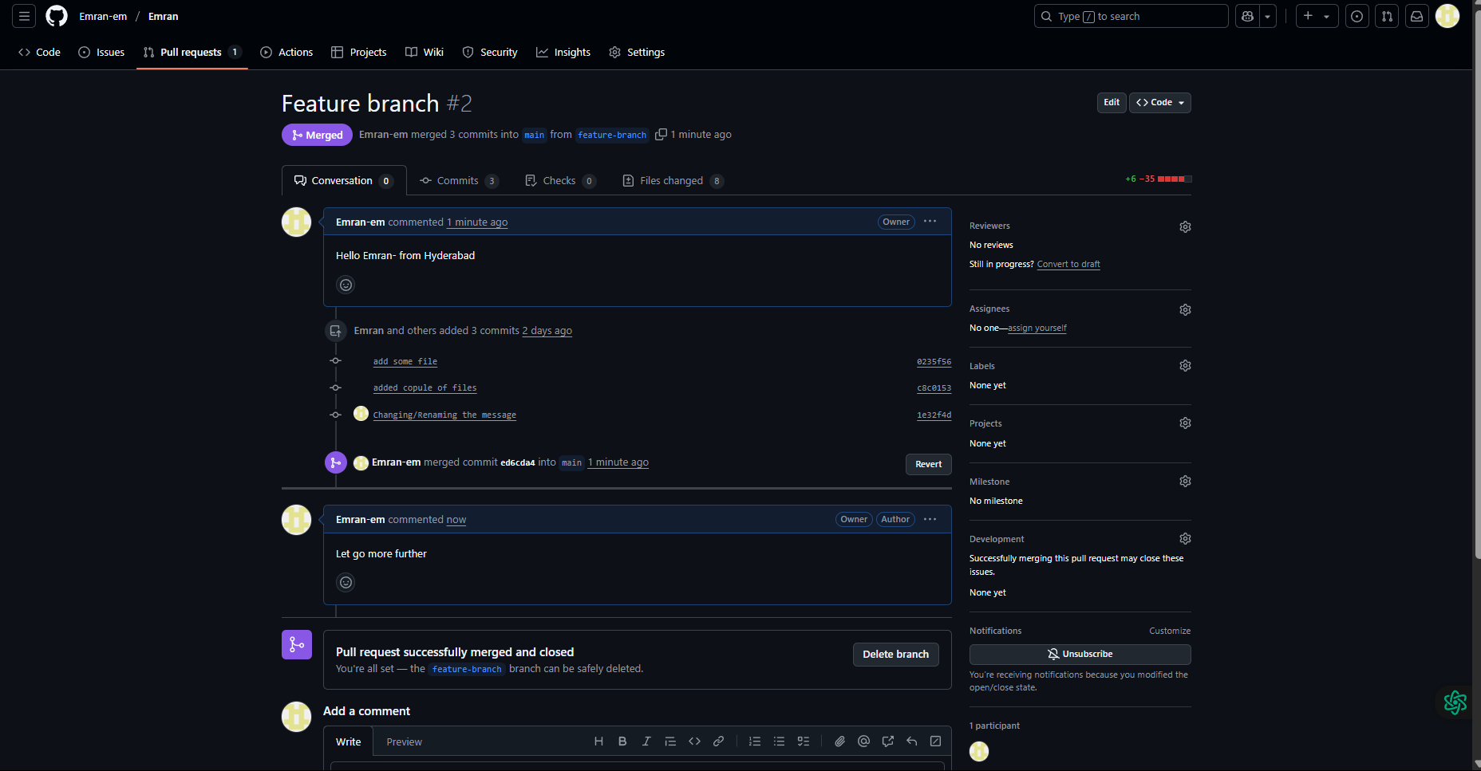
10)create a file in local and send that to branch in github.
git checkout feature-branch
touch newfile.txt
git add newfile.txt
git commit -m "Added new file in feature-branch"
git push origin feature-branch
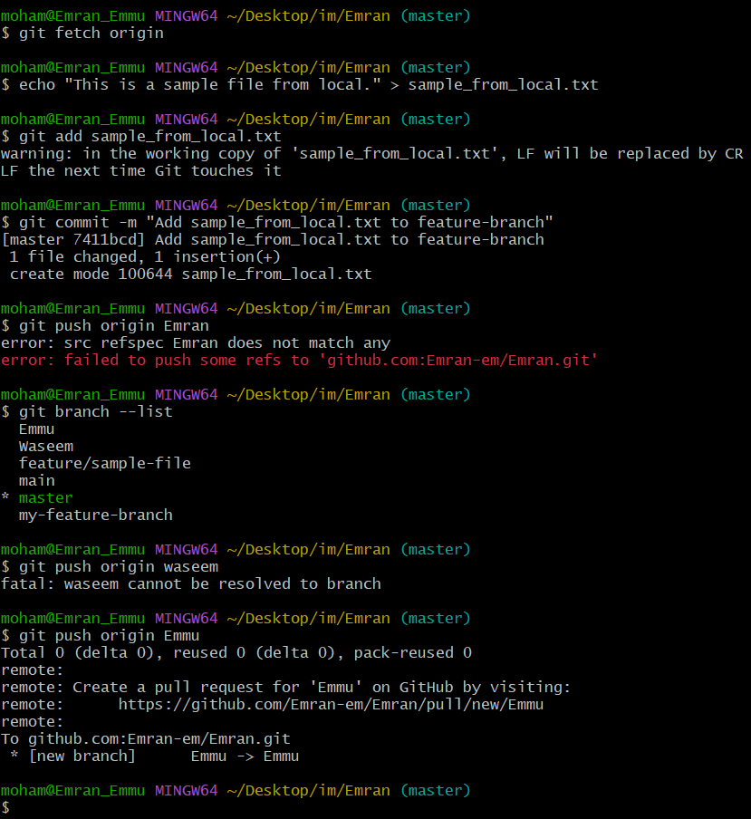
11)clone only a branch from github to local.
git clone -b branch-name --single-branch https://github.com/<username>/<repo>.git
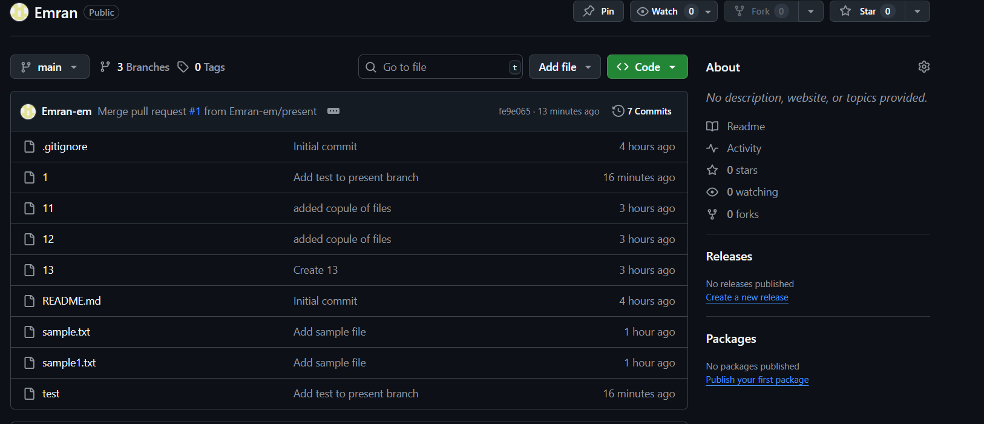
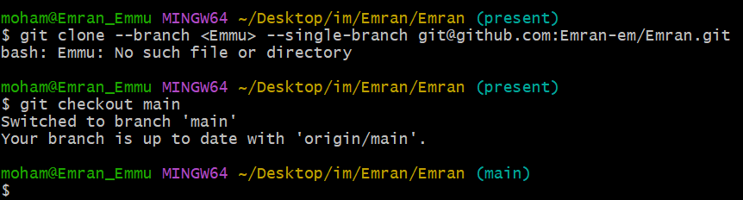
12)create a file with all passwords and make that untrackable with git.
touch passwords.txt
echo "passwords.txt" >> .gitignore
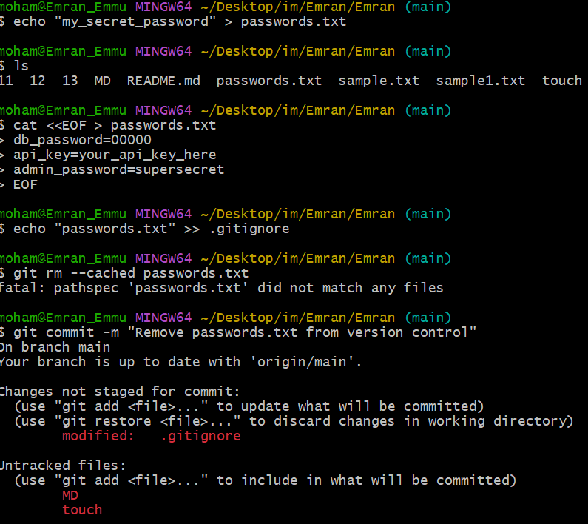
13)make a commit and make that commit reset without savings changes.
touch temp.txt
git add temp.txt
git commit -m "Temporary file"
- Reset and discard changes:
git reset --hard HEAD~1
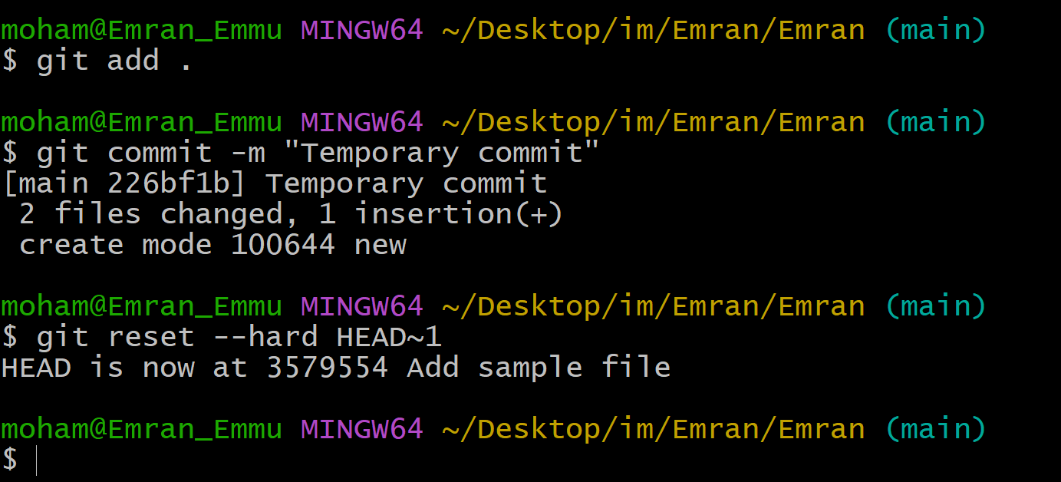
14)Revert a commited commit to the older version.
git log # Copy commit hash
git revert <commit-hash>
git push origin main
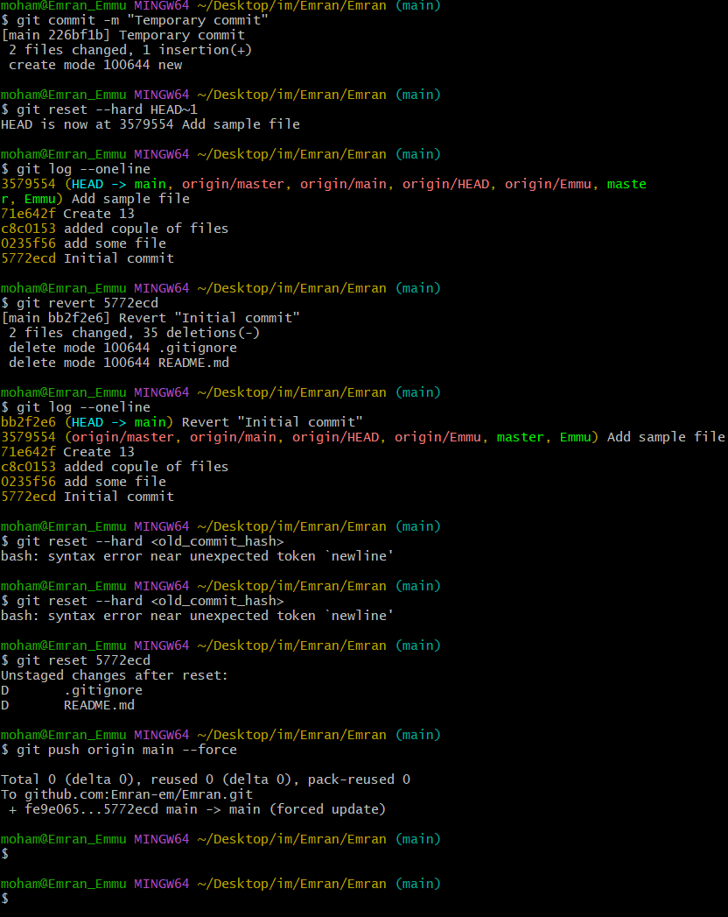
15)push a file to stash without savings the changes and work on another file.
# Edit file1.txt but don’t commit
git stash
# Work on another file
touch another.txt
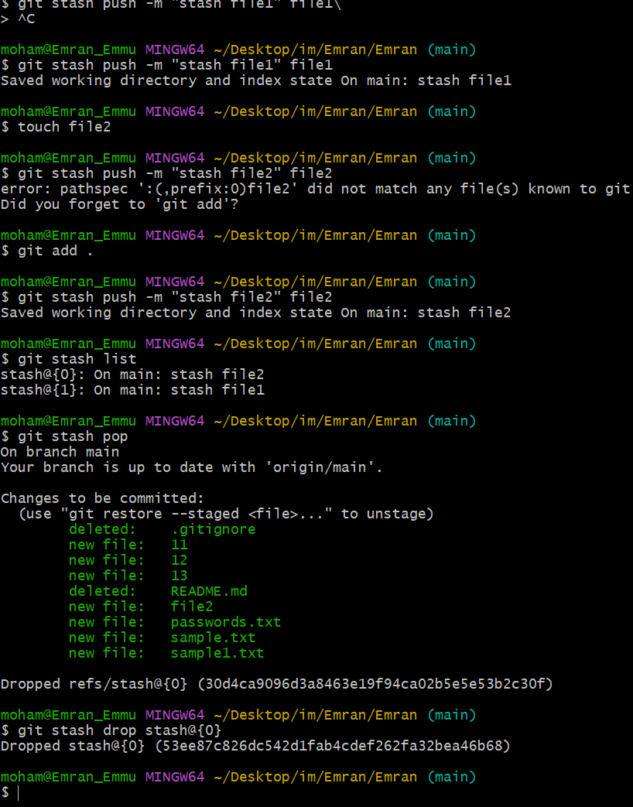
16)undo the stash file and start working on that again.
git stash pop

17)generate a ssh-keygen and configure into github.
ssh-keygen -t rsa -b 4096 -C "your_email@example.com"
cat ~/.ssh/id_rsa.pub
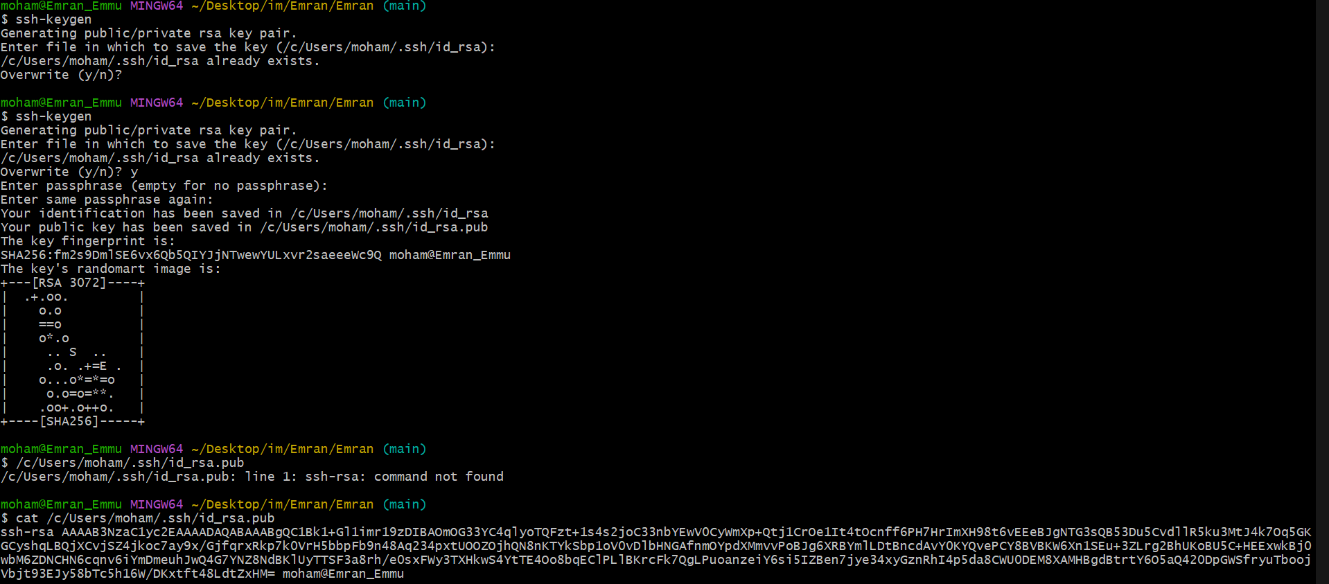
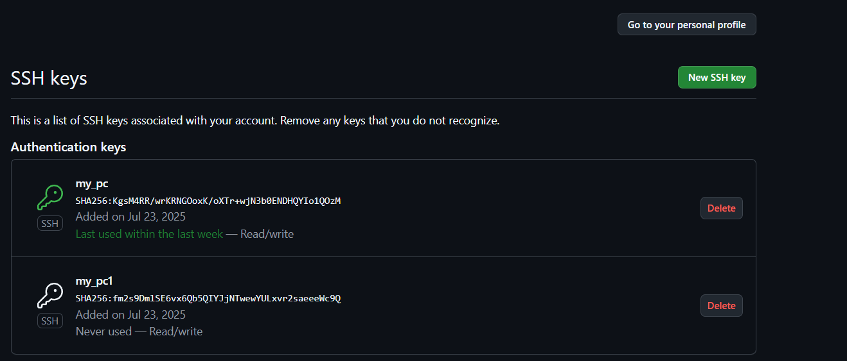
18)configure webhooks to github
Go to GitHub repo → Settings → Webhooks → Add Webhook.
Provide:
- Payload URL: your server endpoint (e.g., Jenkins URL).
- Content type: application/json.
Select events → Add Webhook.

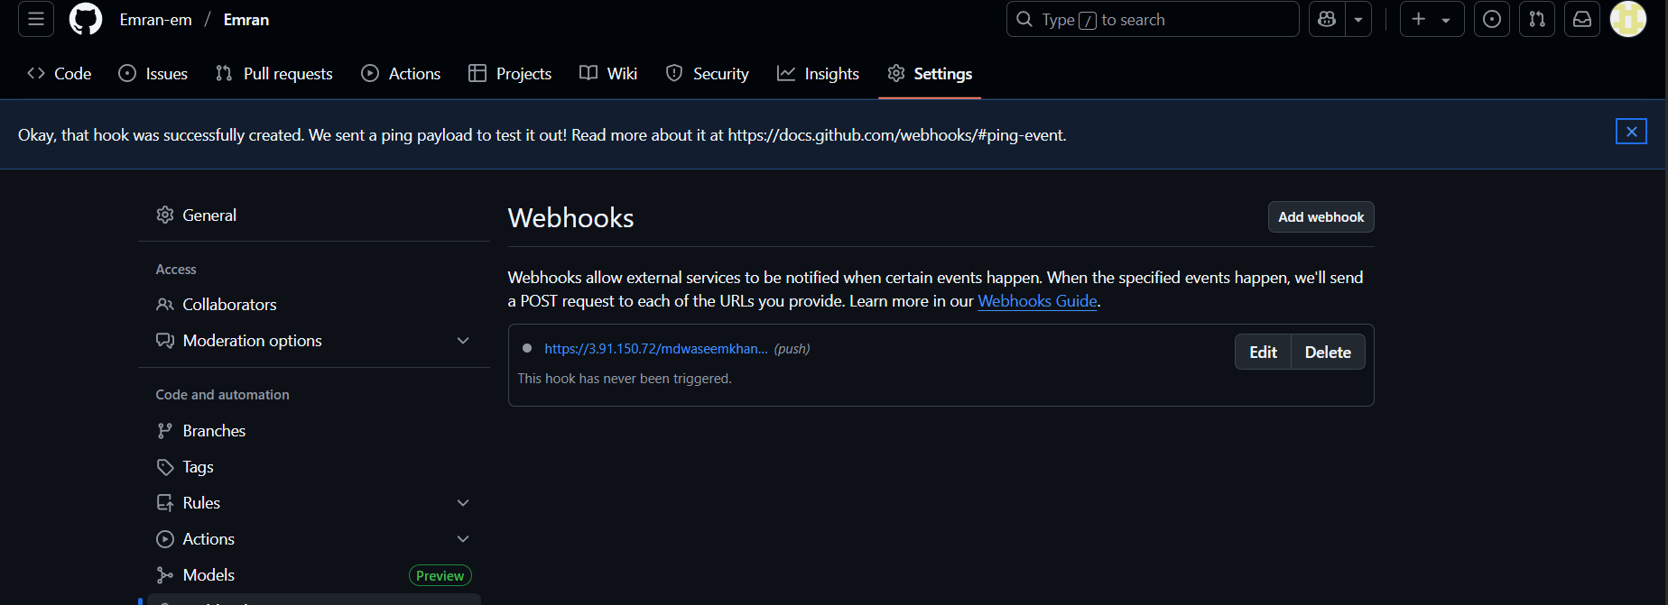.
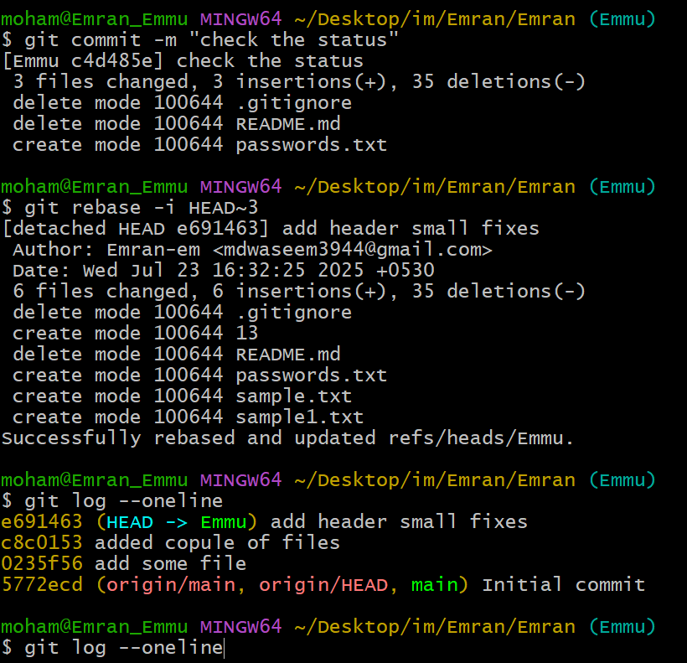
19)basic understanding of .git file.
The .git folder in a repo stores:
- Objects (commits, blobs, trees)
- Refs (branches, tags)
- Config (user info, remotes)
- HEAD (current branch)

Git is a distribution version control system widely used for tracking changes sources code during software development .it allow multiple developers to collaborate on the projects by providing tools for managing code history,branches,merging and more
.git file is a directory is like a database that store all the information about git repo, including … it’s a crucial part of git that helps your track changes, collaborate with other, and manages your codebasae
- Your commit history
- Branch information
- Remote repo details
- Configuration settings
ls .git
20)Check all the logs of git.
git log
git log --oneline --graph --decorate --all
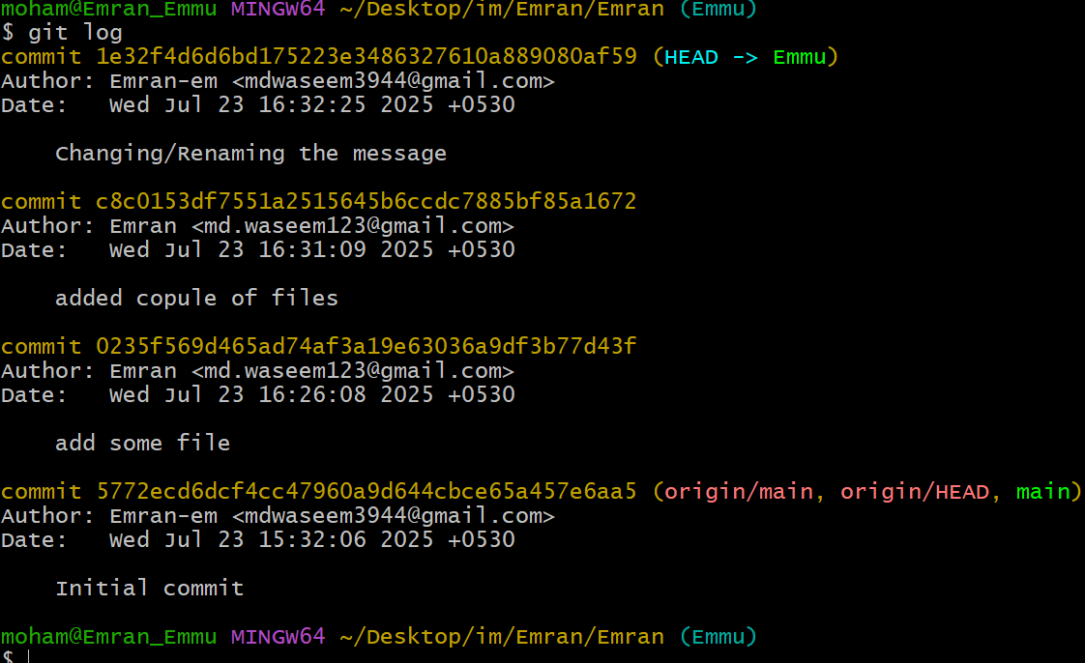
21)Rename the commit message.
git commit --amend -m "New commit message"
git push origin main --force
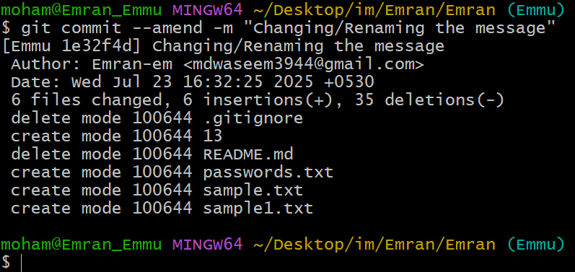
22)Merge multiple commits into single commit.
git rebase -i HEAD~3
# In editor, change 'pick' to 'squash' for commits to combine
# Save and exit
git push origin main --force


